**ASSIGNMENT 5 (28-03-2024)**

1. Create the following two tables:-

Table – S

|  |  |  |  |
| --- | --- | --- | --- |
| **S#** | **SName** | **Status** | **City** |
| S1 | Smith | 20 | London |
| S2 | Jones | 10 | Paris |
| S3 | Blake | 30 | Paris |
| S4 | Adam | 30 | Athens |
| S5 | Clark | 20 | London |

Create table S(S# Varchar2(2),SName VArchar2(8),Status Number(2), City Varchar2(10));

desc S;

Insert into S values('S1','Smith',20,'London');

Insert into S values('S2','Jones',10,'Paris');

Insert into S values('S3','Blake',30,'Paris');

Insert into S values('S4','Adam',30,'Athens');

Insert into S values('S5','Clark',20,'London');

Select * from S;

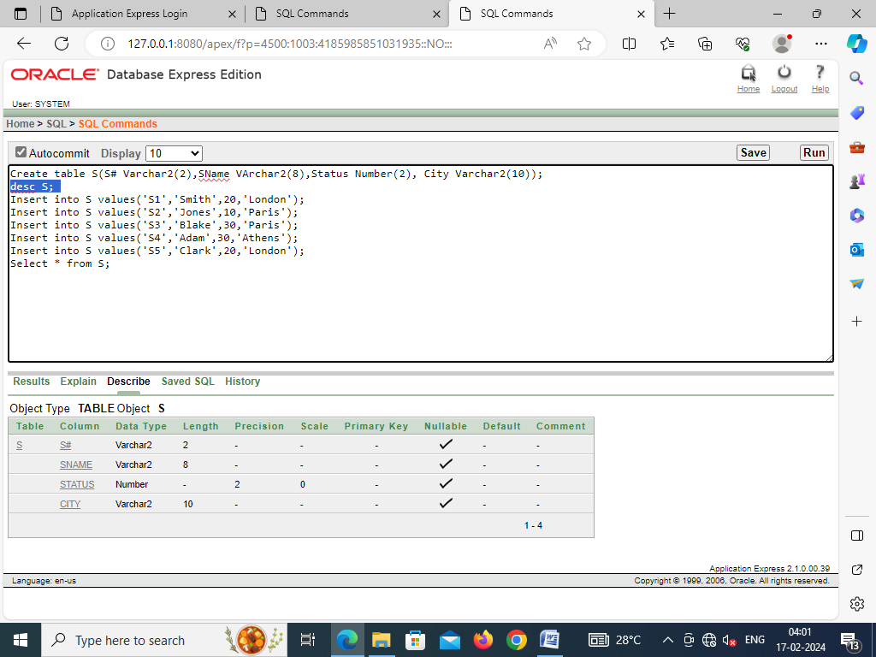

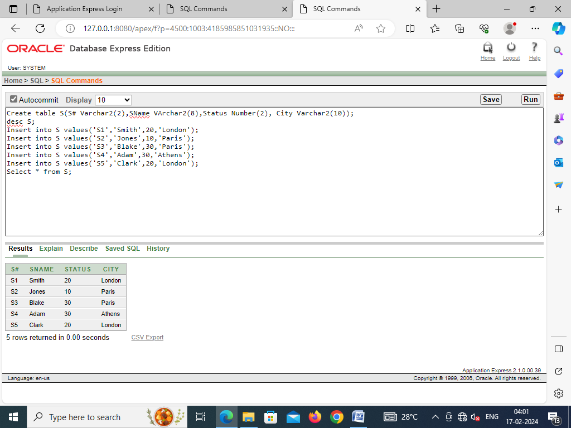

Table - SP

|  |  |  |  |  |
| --- | --- | --- | --- | --- |
| S# | P# | Quantity | Colour | Price |
| S1 | P1 | 300 | Red | 500 |
| S1 | P2 | 200 | Blue | 700 |
| S2 | P1 | 100 | Red | 500 |
| S2 | P2 | 400 | Blue | 700 |
| S3 | P2 | 200 | Blue | 700 |
| S4 | P2 | 200 | Blue | 700 |

Create table SP(S# Varchar2(2),P# Varchar2(2),Quantity Number(3),Colour VArchar2(5), Price Number(3));

desc SP;

Insert into SP values('S1','P1',300,'Red',500);

Insert into SP values('S1','P2',200,'Blue',700);

Insert into SP values('S2','P1',100,'Red',500);

Insert into SP values('S2','P2',400,'Blue',700);

Insert into SP values('S3','P2',200,'Blue',700);

Insert into SP values('S4','P2',200,'Blue',700);

Select * from SP;

